close all

clear

clc

Vth=-50e-3;

Vreset=-80e-3;

sigv=1e-3;

tau=3e-3;

E_L=-70e-3;

E_I=-65e-3;

E_E=0;

G_L=50e-12;

W_EE=25e-9;

W_EI=4e-9;

W_IE=800e-9;

G_in1=1e-9;

G_in2=0;

dt=0.1e-3;

t=0:dt:2.5;

tau_E=2e-3;

tau_I=5e-3;

alpha=0.2;

G_E1(1)=0;

G_E2(1)=0;

G_I1(1)=0;

G_I2(1)=0;

r_1(1)=0;

r_2(1)=0;

s_E1(1)=0;

s_I2(1)=0;

for n = 2:length(t)

G_E1(n) = W_EE*s_E1(n-1) + G_in1;

G_E2(n) = W_EI*s_E1(n-1) + G_in2;

G_I1(n) = W_IE*s_I2(n-1);

G_I2(n) = 0;

V_ss1(n) = (G_L*E_L + G_I1(n)*E_I + G_E1(n)*E_E)/(G_L + G_I1(n) + G_E1(n));

V_ss2(n) = (G_L*E_L + G_I2(n)*E_I + G_E2(n)*E_E)/(G_L + G_I2(n) + G_E2(n));

%update diff eqs vie Euler's method

r_1(n) = r_1(n-1)+(dt/tau)*(-r_1(n-1)+fin(V_ss1(n)));

r_2(n) = r_2(n-1)+(dt/tau)*(-r_2(n-1)+fin(V_ss2(n)));

s_E1(n) = s_E1(n-1)+dt*((-s_E1(n-1)/tau_E)+alpha*r_1(n)*(1-s_E1(n-1)));

s_I2(n) = s_I2(n-1)+dt*((-s_I2(n-1)/tau_I)+alpha*r_2(n)*(1-s_I2(n-1)));

end

f1=figure(1);

plot(t,r_1)

hold on

plot(t,r_2)

xlabel('time');

ylabel('Firing rate');

title('part 1');

legend('r1','r2')

saveas(f1, sprintf('1.png'));

peaks_r1 = findPeaks(r_1);

peaks_r2 = findPeaks(r_2);

spike_times1 = find(peaks_r1)*dt;

spike_times2 = find(peaks_r2)*dt;

frequency_r1 = 1/mean(diff(spike_times1));

frequency_r2 = 1/mean(diff(spike_times2));

% Display the oscillation frequencies

message = sprintf('Firing rate 1 oscillation frequency: %.2f Hz', frequency_r1);

disp(message);

%Firing rate 1 oscillation frequency: 7270.65 Hz

message = sprintf('Firing rate 1 oscillation frequency: %.2f Hz', frequency_r2);

disp(message);

%Firing rate 1 oscillation frequency: 8100.11 Hz

%% Part 3

new_r1=r_1(find(t>=0.5));

[p,F]=periodogram(new_r1,[],[],1/dt);

f2=figure(2);

plot(F(1:500),p(1:500))

xlabel('frequency')

ylabel('periodgram r')

[peak loc]=max(p)

disp(F(loc))

saveas(f2, sprintf('2.png'));

%The f=0 component represents the mean or DC offset of the signal and has the greatest amplitude.Even if the signal oscillates around this mean, the amplitude of the oscillations is typically smaller than the mean value itself.

%we truncate the r1 signal to remove the non-oscilatory part of signal.multiple peaks are representing a frequency at which there is significant power in the firing rate data.The number and location of the peaks are depend on the intrinsic dynamics of the coupled oscillator system

%% part 4

% Define parameters

G_in2 = 0; % Input to inhibitory cells (constant)

G_in1_range = 0:0.1e-9:10e-9; % Range of input to excitatory cells

G_E1(1)=0;

G_E2(1)=0;

G_I1(1)=0;

G_I2(1)=0;

r_1(1)=0;

r_2(1)=0;

s_E1(1)=0;

s_I2(1)=0;

i=1;

G_in1_range= 0:0.1e-9:10e-9;

% Simulation loop

for i=1:length(G_in1_range)

G_in1=G_in1_range(i);

% Simulate network dynamics

for n = 2:length(t)

G_E1(n) = W_EE*s_E1(n-1) + G_in1;

G_E2(n) = W_EI*s_E1(n-1) + G_in2;

G_I1(n) = W_IE*s_I2(n-1);

G_I2(n) = 0;

V_ss1(n) = (G_L*E_L + G_I1(n)*E_I + G_E1(n)*E_E)./(G_L + G_I1(n) + G_E1(n));

V_ss2(n) = (G_L*E_L + G_I2(n)*E_I + G_E2(n)*E_E)./(G_L + G_I2(n) + G_E2(n));

%update diff eqs vie Euler's method

r_1(n) = r_1(n-1)+(dt/tau)*(-r_1(n-1)+fin(V_ss1(n)));

r_2(n) = r_2(n-1)+(dt/tau)*(-r_2(n-1)+fin(V_ss2(n)));

s_E1(n) = s_E1(n-1)+dt*((-s_E1(n-1)/tau_E)+alpha*r_1(n)*(1-s_E1(n-1)));

s_I2(n) = s_I2(n-1)+dt*((-s_I2(n-1)/tau_I)+alpha*r_2(n)*(1-s_I2(n-1)));

end

new_r1=r_1(find(t>=0.5));

new_r2=r_2(find(t>=0.5));

new_r1=new_r1-mean(new_r1);

new_r2=new_r2-mean(new_r2);

[p1,F1]=periodogram(new_r1,[],[],1/dt);

[p2,F2]=periodogram(new_r2,[],[],1/dt);

[max_power, max_index] = max(p1);

% Extract the frequency corresponding to the maximum power

frequency_at_max_power = F1(max_index);

oscillation_frequency1(i)=frequency_at_max_power;

[max_power2, max_index2] = max(p2);

frequency_at_max_power2 = F2(max_index2);

oscillation_frequency2(i)=frequency_at_max_power2;

peaks_r1 = max(p1)-min(p1);

peaks_r2 = max(p2)-min(p2);

excitatory_amplitude1(i) = peaks_r1;

inhibitory_amplitude2(i) = peaks_r2;

mean_excitatory(i) = mean(p1); % Mean firing rate of cell 1

mean_inhibitory(i) = mean(p2); % Mean firing rate of cell 2

end

% Plot figures

f3=figure;

subplot(2,2,1);

plot(G_in1_range, oscillation_frequency1);

hold on

plot(G_in1_range, oscillation_frequency2);

xlabel('stimulus amplitude');

ylabel('Oscillation Frequency (Hz)');

legend('E', 'I');

title('Oscillation Frequency vs. G_{in1}');

subplot(2,2,2);

plot(G_in1_range*1e9, excitatory_amplitude1);

hold on;

plot(G_in1_range*1e9, inhibitory_amplitude2);

xlabel('stimulus amplitude');

ylabel('Oscillation Amplitude');

legend('E', 'I');

title('Oscillation Amplitude vs. G_{in1}');

subplot(2,2,3);

plot(G_in1_range*1e9, mean_excitatory);

hold on;

plot(G_in1_range*1e9, mean_inhibitory);

xlabel('stimulus amplitude');

ylabel('Mean Firing Rate');

legend('E', 'I');

title('Mean Firing Rate vs. G_{in1}');

saveas(f3, sprintf('3.png'));

function fout = fin(V_ss)

Vth=-50e-3;

Vreset=-80e-3;%-0.08

sigv=1e-3;

tau=3e-3;

if V_ss==Vth;

fout=sigv/(tau*(V_ss-Vreset));

else

fout=(V_ss-Vth)/(tau*(Vth-Vreset)*(1-exp(-(V_ss-Vth)/sigv)));

end

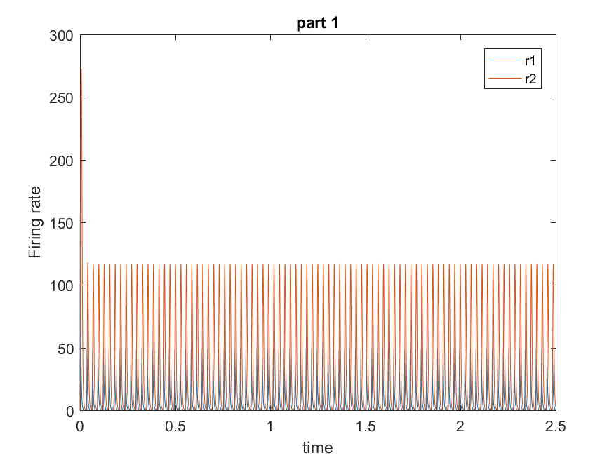

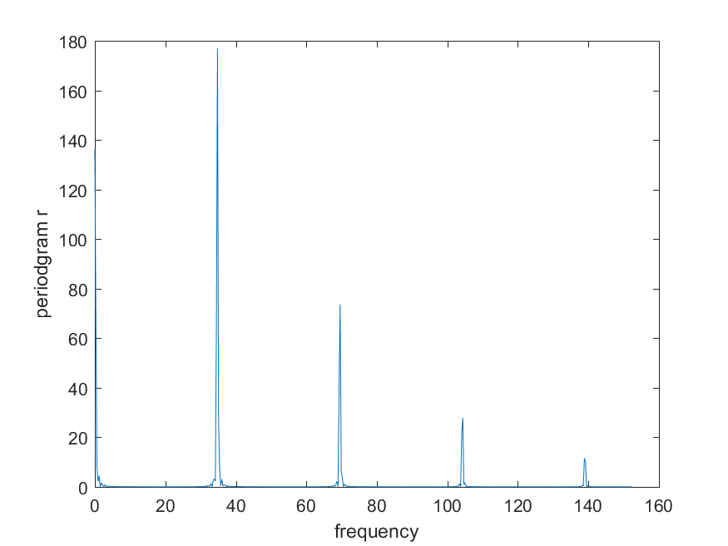

Firing rate 1 oscillation frequency: 34.79 Hz

Firing rate 2 oscillation frequency: 47 Hz

The f=0 component represents the mean or DC offset of the signal and has the greatest amplitude. Even if the signal oscillates around this mean, the amplitude of the oscillations is typically smaller than the mean value itself.

We truncate the r1 signal to remove the non-oscillatory part of the signal. Multiple peaks represent frequencies at which there is significant power in the firing rate data. Based on the graph, I can see that these presenting frequencies are multiples of each other. It seems that these multiple peaks are harmonics of a fundamental frequency; firing rate signals exhibit harmonics due to the inherent periodicity of neural firing patterns.

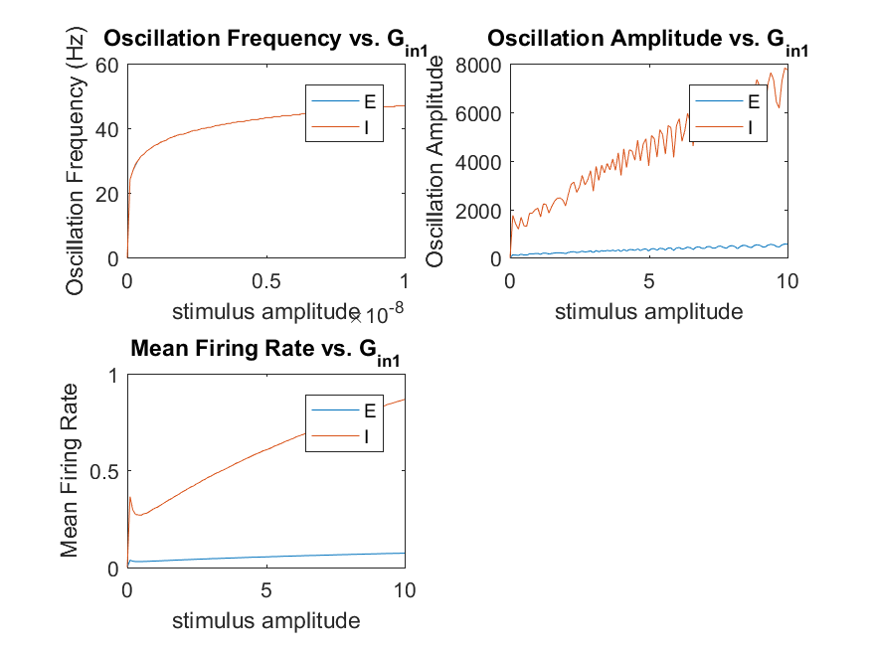

The frequency of oscillation increases within the gamma range, from below 30 Hz to 50 Hz, as excitatory

input to the excitatory unit is increased. As the excitatory input to the E-unit increases, it requires a stronger inhibitory response from the I-unit to maintain the oscillation balance. To achieve this, the amplitude (strength) of the inhibitory signal from the I-unit needs to be larger to effectively counter the stronger excitation. This results in a rise in the amplitude of the inhibitory cell's oscillation. The mean firing rates of both units increase as the oscillation amplitude increases, though mean firing rate of the E-unit remains below the oscillation frequency, an indication that individual cells fire spikes on intermittent gamma cycles.